Vocabulary Strategy #3
from Inside Words by Janet Allen

Possible Sentences

What Is the Possible Sentences Strategy?

Possible Sentences is a prereading strategy that gives students the opportunity to predict the content of upcoming reading based on targeted vocabulary words. Students use two or more of the words in a sentence that they predict will occur in the upcoming text. It also serves as an activity that can help students monitor comprehension during reading and review content after reading.

This is probably one of the best instructional activities for building background knowledge with targeted vocabulary words. Students enjoy the activity and read more carefully than they might otherwise because they are looking for their words and the accuracy of their sentences.
How Does It Work?

- Select words from the text that are critical to students’ understanding of the reading. Choose a combination of words; some new and some words that are familiar to them. However, all should be significant in the text.
- Read each of the targeted words aloud.
- Assign student groups and ask students to write sentences they believe they will read in the text. At this time you may want to either talk about or do a read-aloud of a passage that builds context for the words they will encounter. They should use two or more words in each sentence but they should not use so many words that the sentence is hard to revise.
- Each group contributes one or more of their sentences and the teacher posts sentences on co-constructed chart. Any words not used in sentences generated by the small groups are now created by the entire class. All words in the target list should be used.
- Students use their sentences as support while reading the text. They mark each of their sentences as true, false, or unknown based on the accuracy of their content compared to the text. If the sentences are inaccurate in terms of the text’s comments, they revise their sentences using the target words so their sentences accurately reflect the content.

When and Why Would I Use This Strategy?

The strategy is an ideal way to build background knowledge and generate student interest in a text. Having seen and worked with the targeted vocabulary words creates a natural curiosity about the accuracy of their predictions. The interest sustains them throughout the reading of their text and serves as an excellent tool for synthesizing and summarizing the most significant information and ideas in what students have read.

Example 1: A high school social studies teacher has her student participating in a Possible Sentences activity before they read about the Triangle Shirtwaist Fire.

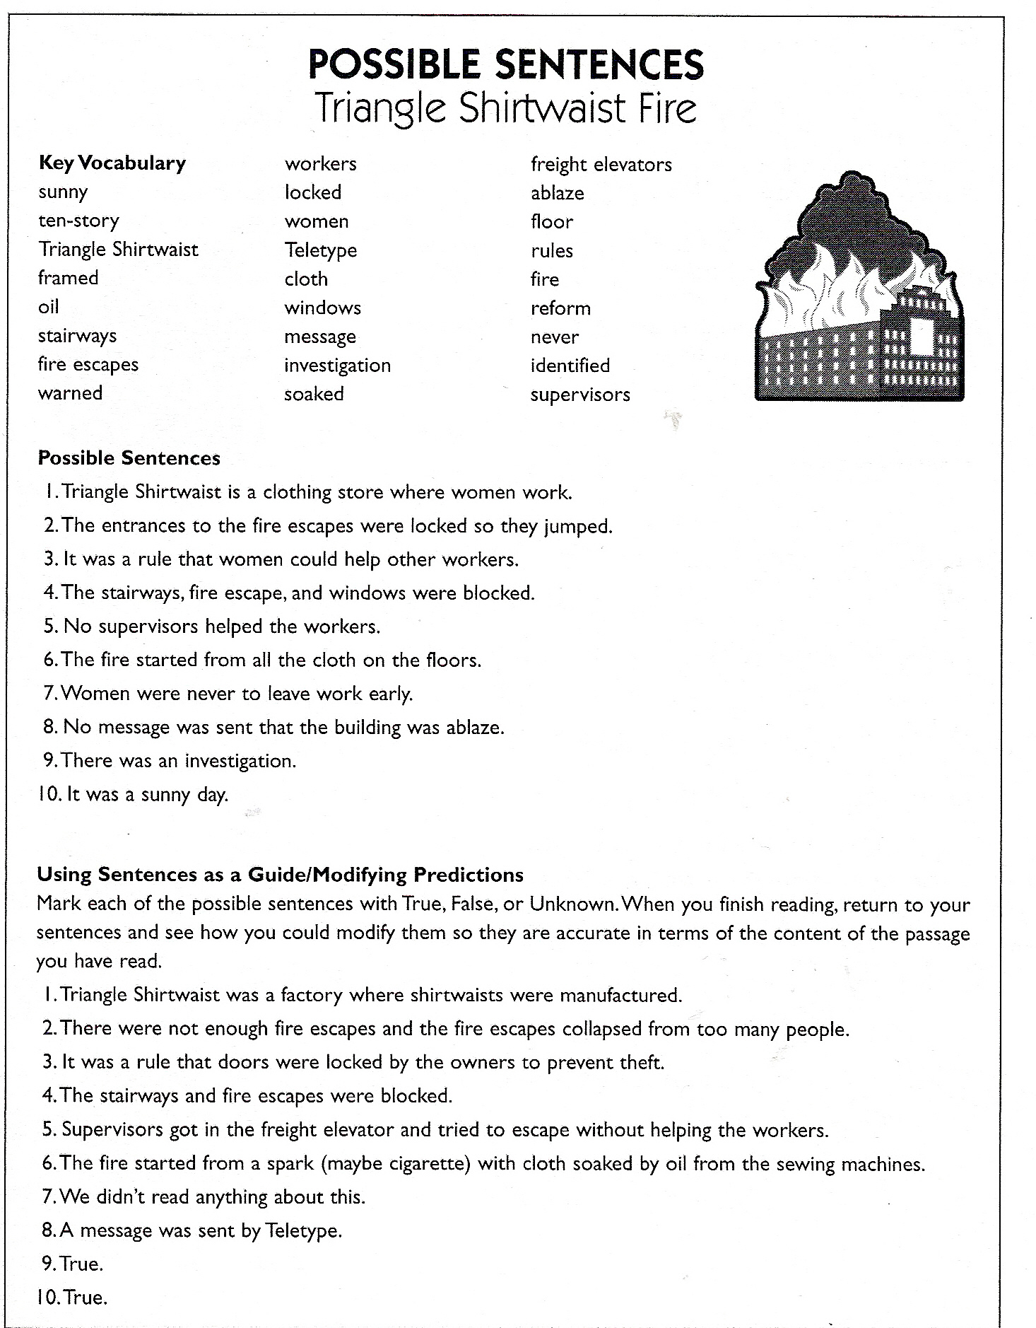

Example 2: An elementary science teacher has her students participating in the activity before a shared reading of a chapter from their science book.

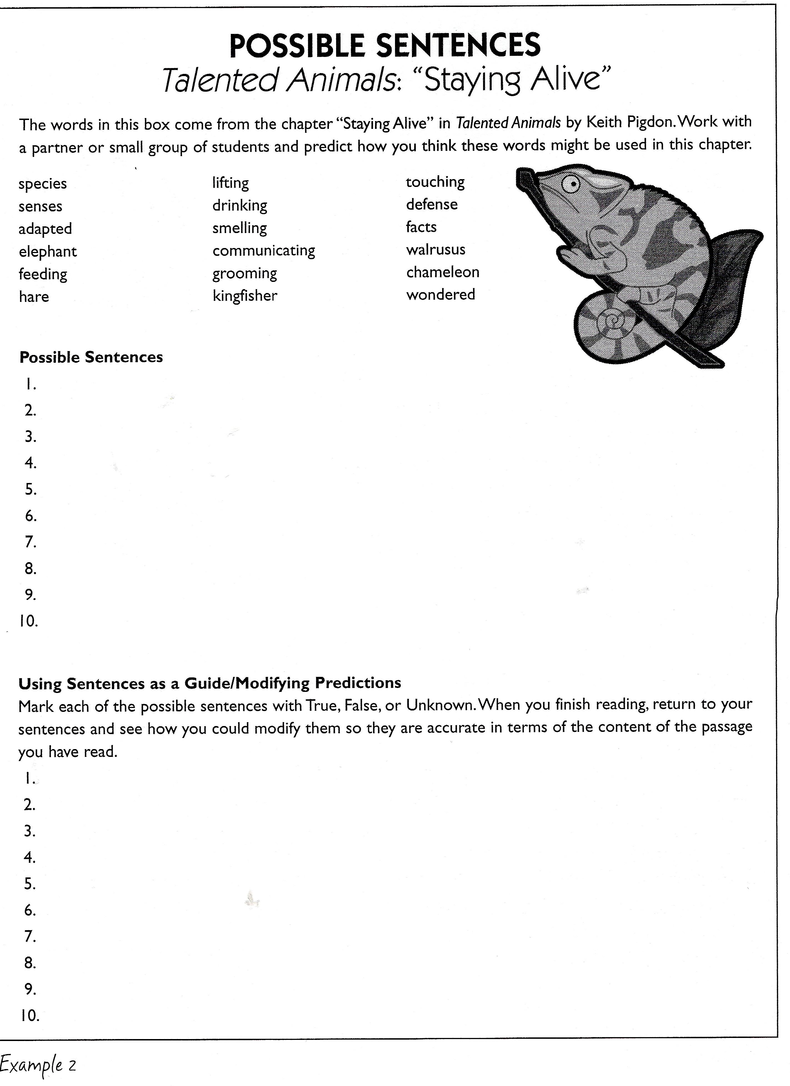
The structure and the purpose of the activity remain the same regardless of students’ ages and the complexity of the text.

