The Instructional Strategy for October is

Summarizing &
Note Taking

Generalizations about Summarizing & Note Taking  Students should learn to eliminate unnecessary information, substitute some information, keep important information, write / rewrite, and analyze information. Students will learn to put information into their own words and how to synthesize information accurately and concisely.  Read more:  http://www.netc.org/focus/strategies/summ.php  Teacher models summarization techniques, identify key concepts, bullets, outlines, clusters, narrative organizers, journal summaries, break down assignments, create simple reports, quick writes, graphic organizers, column notes, affinity diagrams, etc. | Marzano’s Summary Frames:  - Narrative Frame  - Topic-Restriction-Illustration Frame  - Definition Frame  - Argumentation Frame  - Problem/Solution Frame  - Conversation Frame  http://sddial.k12.sd.us/esa/doc/teachers/marzano/SummaryFrames.pdf  templates:  http://classroom.leanderisd.org/webs/marzano/summarizing_and_note_taking.htm | Formats for Notes:  - informal Outline  - Webbing  - Combination Notes | 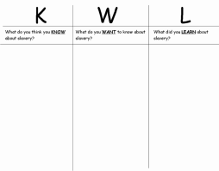
A to Z Review & TILT Journals:
http://msbinstructionalcoach.wordpress.com/teaching-tip-tuesday-archives/
- Students write a summary statement starting with a letter of the alphabet
- Students keep a TILT journal “Things I learned today…” & write in it at the end of class.
Group Summary  http://www.readingquest.org/edis771/group_sum.html  1. Designate and label a section of the chalkboard for each major heading of the text the class is going to read.  2. After reading each section of the text, students will write main idea statements on the board for each section. Rules: in their own words, complete sentences, include the topic and important info/big ideas from the section.  3. Combine all of the summary statements into a group summary for the entire text. | Shaping Up Review  http://msbinstructionalcoach.wordpress.com/  2012/05/15/  teaching-tip-tuesday-shaping-up-review/  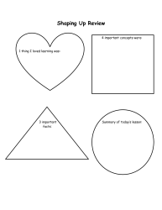 | Cornell Notes  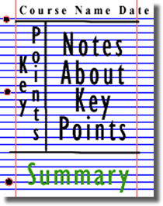  Students divide the paper into 3 sections. On the left they write key points, on the right are notes/info about the key points. At the bottom, students write a summary.  http://coe.jmu.edu/learningtoolbox/cornellnotes.html
Exit Slips  During last 5 minutes of class, students must write a one sentence summary of what they learned that day, make a list of facts learned, etc. | 3-2-1  http://msbinstructionalcoach.wordpress.com/  2012/05/09/teaching-tip-tuesday-3-2-1/  • 3 things that I learned from this lesson/from this text.  • 2 questions that I still have.  • 1 aspect of class/the text that I enjoyed. | INSERT note-taking  http://msbinstructionalcoach.wordpress.com/  2012/04/17/teaching-tip-tuesday-insert/  - During reading, students will place post-it notes in the margin of the text with their reactions, thoughts, and notations.  - After reading, students use their post-its to explain/summarize their learning on paper
Foldables
http://www.csun.edu/~krowlands/Content/Academic_Resources/Foldables/Basic%20Foldables.pdf
Chalk Talk  http://msbinstructionalcoach.wordpress.com/2012/04/03/  teaching-tip-tuesday-chalk-talk/ | Reciprocal Teaching  - In groups of 4, students will each be given a role: summarizer, questioner, clarifier, predictor  - Have students read a few paragraphs of the assigned text and use note-taking strategies (selective underlining or sticky notes)  - At the given stopping point, each student will do their job of summarizing, clarifying, questioning, or predicting.  - The roles then switch, one person to the right. The next section is read. Students repeat the process using their new roles. This continues until the entire selection is read.  For more info on the tasks for each role and graphic organizers to use: http://www.readingrockets.org/strategies/reciprocal_teaching/
RAFT http://www.adlit.org/strategies/19783/
A writing strategy that helps students present their ideas about content information they are studying by responding to prompts that require them to think about various perspectives:
R: role of the writer F: format
A: audience T: topic

