D 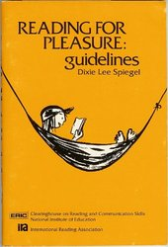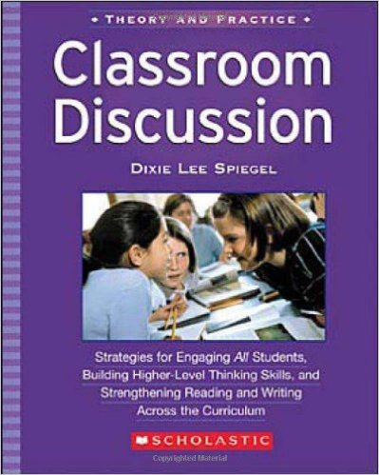
“Her advocacy for the struggling reader and her spirited faith in teachers' ability to reform their own teaching are hallmarks of her scholarship.” - See more at: http://soe.unc.edu/news_events/news/2005/spiegel_dixie.php#sthash.ClWMg87Y.dpuf
EXPECTATION OUTLINE
Purpose: To help students ask questions/make predictions about text. The expectation outline is developed on the board or an overhead as students tell what they expect to learn from a reading selection.
1. After the students have previewed the material, ask them what they think the selection will be about. The students should give their predictions as questions.
2. As the students give their questions, group related questions on the Smartboard or Elmo - Encourage students to tell what prompted them to ask their question.
3. After the questions have been asked and grouped, the class labels the groups of questions. The students will see major topics that will emerge from the reading.
4. If there is important information the students have missed, the teacher can fill this in on the expectation outline and call the students’ attention to it. Once the expectation outline is complete the students read to answer the questions they have asked.

